**Vivekanand Education Society’s Institute of Technology  
  
Subject: Professional Communication and Ethics - 2  
Semester V**



**Since 1962**

**Assignment 1**

**Department:** Artificial Intelligence & Data Science.

**Class & Div:** D11AD

**Subject Teacher:** Dr. Geeta Ajit

| Name of the Student: Yash Sarang | Roll No: 47 |
| --- | --- |
| Title: Cover Letter and Resume. | Assignment no.: 1 |
| Date of Submission: 17/10/22 |  |
| Signature: Dr. Geeta Ajit | GRADE: |

**Resume:**

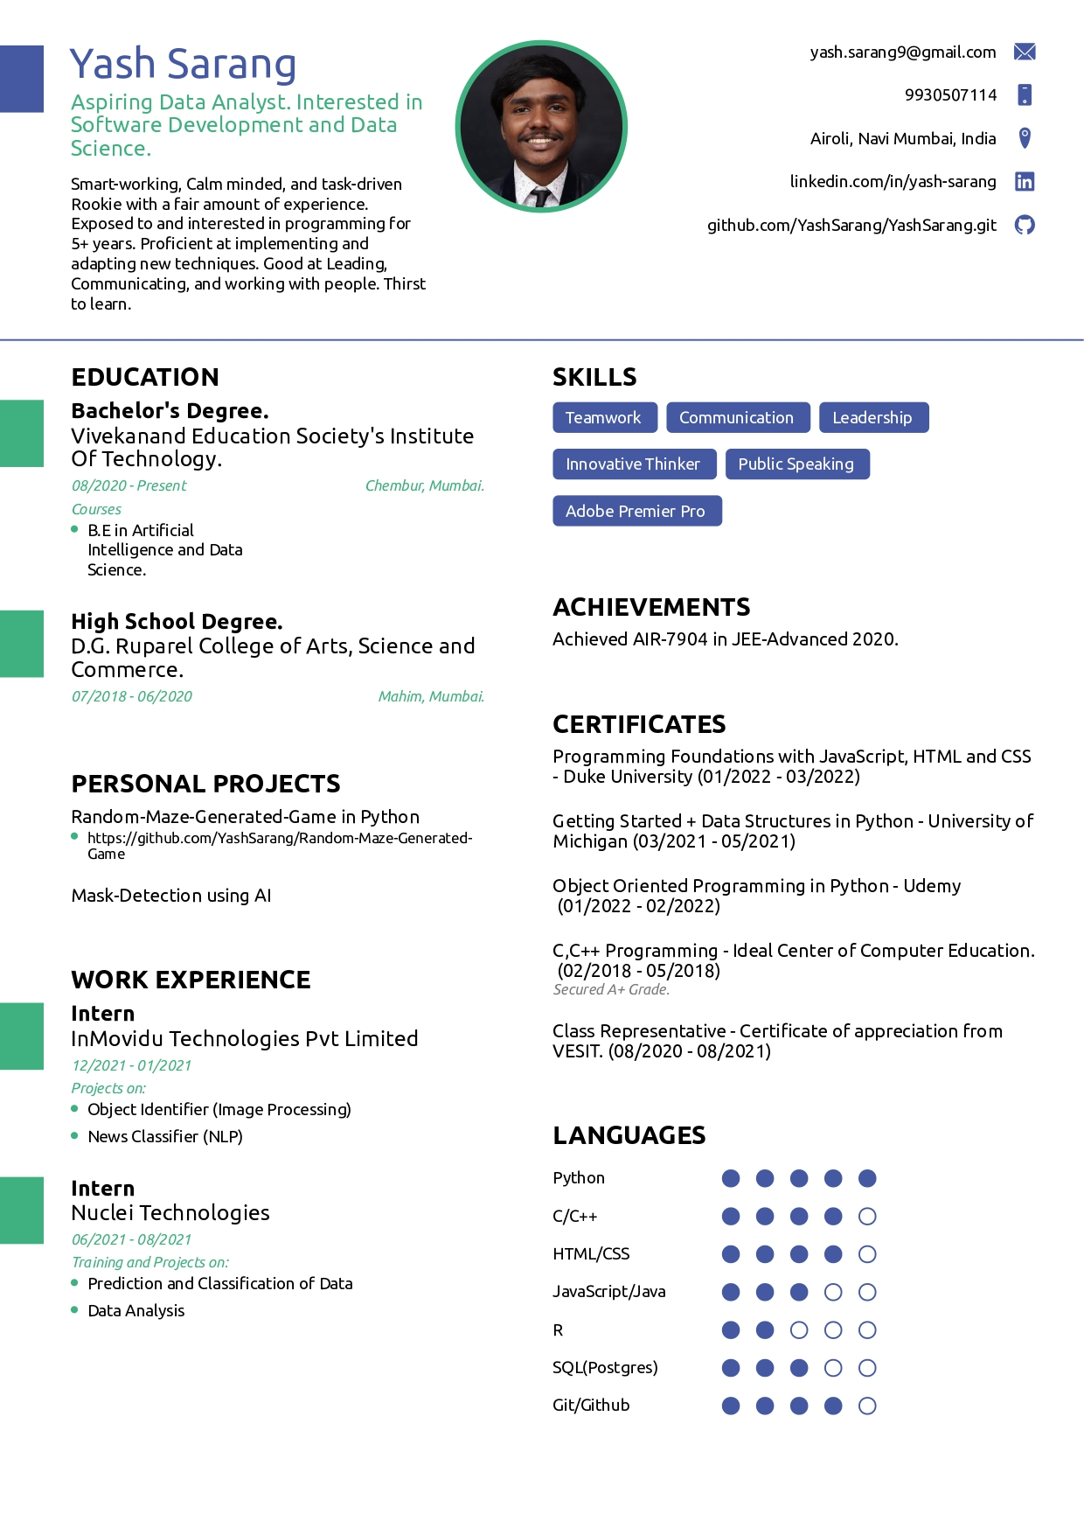

**Job Advertisement**Link: <https://g.co/kgs/ojhZMb>

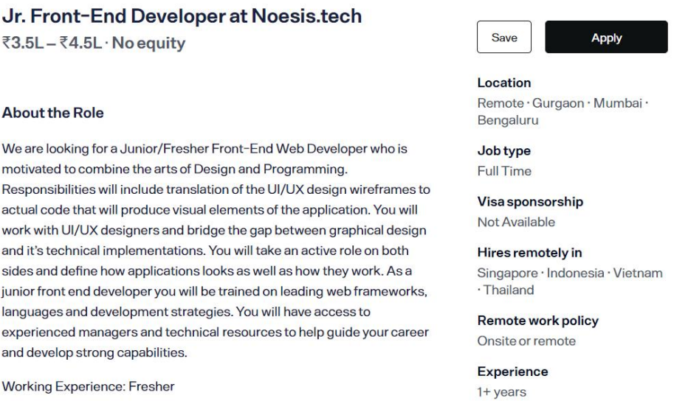

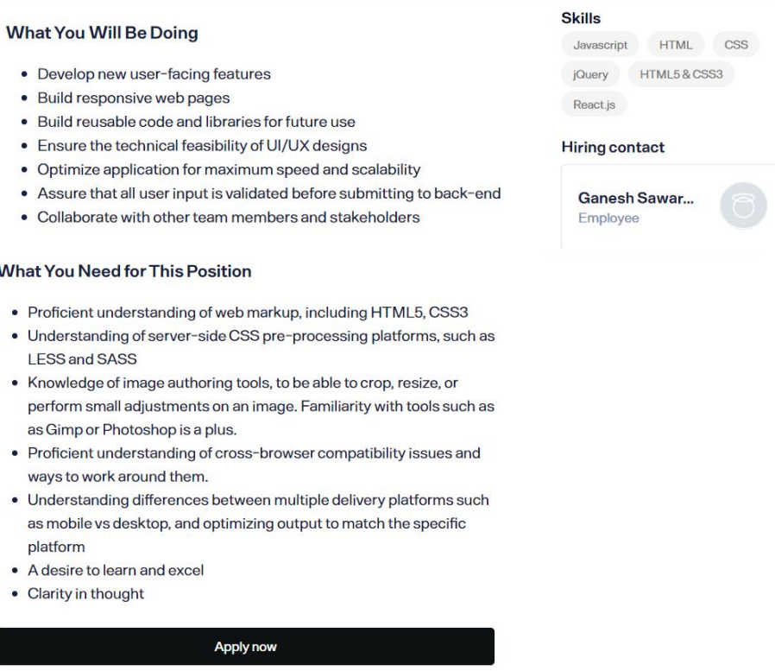

**Cover Letter**

Yash Sarang   
Airoli, Navi Mumbai, Maharashtra 400 708.  
9930507114 | 2020.yash.sarang@ves.ac.in

September 27, 2022,

Noesis.tech   
105 Regal Diamond Center, Opera House,   
Mumbai, Maharashtra - 400 004

RE: Jr. Front End Developer

Respected Hiring Manager,

I was excited to learn about the Jr. Front End Developer position with Noesis.tech posted on your company website and would greatly appreciate your considering my placement in this role. I've closely reviewed the needs and requirements for this role and believe that my qualifications have prepared me to contribute immediate value to your organization.

While in college, I worked hard to hone my HTML, CSS, and Javascript skills. I am focused and attentive to detail when addressing high-volume task loads to meet deadlines. I am inspired by making a positive impact by applying Frontend skills and my problem-solving abilities allow me to address challenges to achieve results.

My academic experiences have served me well in developing my problem-solving, teamwork, and time-management skills. I work well to use clear and concise communication to interact professionally with co-workers, supervisors, and customers. I look forward to speaking with you regarding my skill set and attributes which I believe will serve as an asset to support Noesis.tech's goals. Please take a moment to review my attached resume. Thank you for your time and consideration.

Sincerely, Yash Sarang.

**\*\*\*\*\***